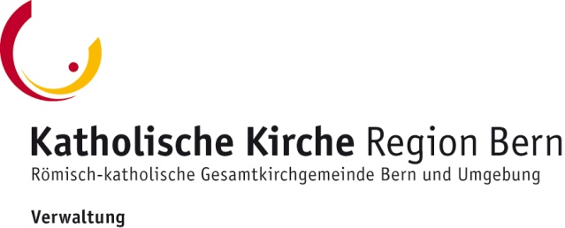

Committee for Development Cooperation and Missions
Grant Application Form
Please send by post or, preferably, via email to global@kathbern.ch
(Post address: Katholische Kirche Region Bern, Frohbergweg 4, Postfach, CH-3001 Bern)
For more information go to www.kathbern.ch/global
You will receive a confirmation via E-Mail. Should you not hear from us within a week, please contact us immediately.)

- General information
Project number, year | Leave this box empty
Project Name | Click here to fill in
Country | Click here to fill in
Region / Continent | Click here to fill in
Applicant Organisation  - Name  - Address  - Phone  - Email  - Web page | Click here to fill in
Bank account (IBAN) including name of account holder and address  BIC (for foreign payments only) | Click here to fill in
Type of project | Please tick all that apply:  Innovation or project start-up  Overheads, ongoing project  One-off project

- Questions about the application
  - Applicant Organisation
Name of the local project organisation  (who is behind the project) | Click here to fill in
Name of on-site project manager | Click here to fill in
Name of the responsible organisation in Switzerland | Click here to fill in
Contact person in Switzerland | Click here to fill in
Other organisations involved, or important co-operations | Click here to fill in
Name of the responsible organisation’s supervisory authority; please indicate if certified under Swiss certification rules (ZEWO) | Click here to fill in
Responsible body for meeting financial conditions | Click here to fill in
Your connection to the Catholic Church | Click here to fill in
Your connection to Bern (in general or the Catholic Church of Bern) | Click here to fill in
Has your organisation previously been supported by us? If so, provide year, project name, grant awarded. | Click here to fill in

  - Funding
Grant requested | Click here to fill in
Overall project costs, in Swiss Francs (please enclose budget) | Click here to fill in
Amount of services on own account
- in Switzerland | Click here to fill in
- by the local partner organisation | Click here to fill in
- by the beneficiaries | Click here to fill in
Other funding received (state the amount awarded and the donor) | Click here to fill in
Please state any other bodies you are sending applications to | Click here to fill in

- Questions about the project
Describe the project’s main objective
Please append a detailed project description
Click here to fill in
Describe the project setting (geographical, economic, political, social, etc. aspects)
Click here to fill in
Describe the aims you wish to obtain
Click here to fill in
Describe the project’s target group(s) (beneficiaries)
Click here to fill in
The number of people to be reached
Click here to fill in
Starting date and duration (planning schedule)
Click here to fill in
Describe the target long-term effect of the project
Click here to fill in
The date the Project Completion Report (including statement of expenditure) will be sent to Catholic Church Greater Bern
Click here to fill in

- Attachments
Detailed project description
For construction projects: building plans
Budget and funding plan
- Supplementary information
Please provide any photos or illustrations already available for public relations. | Click here to fill in
Any other information | Click here to fill in

- Obligations
Catholic Church Greater Bern  (Roman Catholic Authority Greater Bern) | Applicant Organisation
Responsibility for the project
- Catholic Church Greater Bern confirm reception of application by email and informs about the decision made.  - Catholic Church Greater Bern commit to pay the grant awarded in full.  - The amount of grant awarded cannot be increased in the event of overspend. | - Applicant Organisation is responsible for diligently spending the grant awarded for the purpose intended.  - Applicant Organisation is liable if the funds are used inappropriately.  - Any changes to the project are subject to the explicit approval by Catholic Church Greater Bern.
During and after the project
- Catholic Church Greater Bern is entitled to ask about the project’s progress at any time.  - Catholic Church Greater Bern regularly checks that the grant awarded is used appropriately.  - Catholic Church Greater Bern may take steps to ensure the appropriate use of funding in case of any deviation from these Obligations. | - Applicant Organisation will keep Catholic Church Greater Bern informed about the project’s progress.  - The Project Completion Report must be handed in to Catholic Church Greater Bern without a reminder.  - The Project Completion Report must address all items listed in the Grant Arrangement.
Financial duties
- Payments will only be made through officially recognised channels and institutions. | - Applicant Organisation is responsible for the appropriate use of the grant awarded.  - Applicant Organisation, project managers, or third parties are not allowed to accept gifts of any kind in the scope of this project.
Contingencies
- Acts of God such as natural disasters, political unrest or war may impede the realisation of the project.  - In any such event, Catholic Church Greater Bern may suspend or even retract their support; the latter only after consulting with the applicant. | - Applicant Organisation will immediately inform Catholic Church Greater Bern about any changes to the project or the planning.
Communication
- Catholic Church Greater Bern may publicly inform about their support of the project, e.g. in their annual report, the Bernese parish newspaper, their website, www.kathbern.ch, or other interested media.  - Catholic Church Greater Bern will supply their logo or information as needed. | - Applicant Organisation will acknowledge Catholic Church Greater Bern’s funding in all written materials and information media (e.g. website).
- Signatures
Date and Place  Click here to fill in | Signature Applicant Organisation  Click here to fill in
Date and Place  Click here to fill in | Signature Project CFO  Click here to fill in
Date and Place  Click here to fill in | Signature Project Manager  Click here to fill in

